**LAB REPORT 0**

(Names) Jack Davis and Ronald Cheung

(Date) 9/15/20

Screenshot + Components:

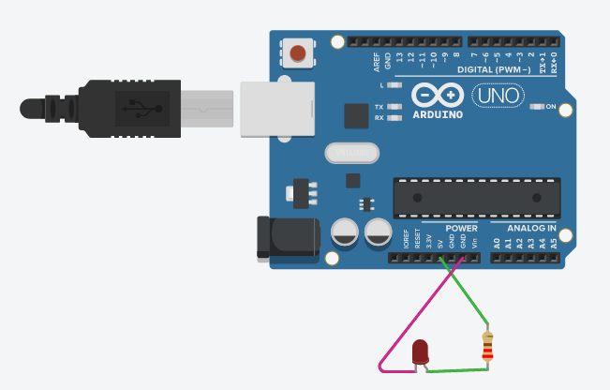

* LED – Stands for Light Emitting Diode. Can only be powered one way. We needed to use a resistor to lower the voltage that the LED was receiving.
* Resistor – …

Summary:

* We created a simple circuit to test out the Arduino and get comfortable with tinkercad. First, we connected the resistor and LED together. It is important that the power(5v) is connected to the right leg of the resistor. The LED was continuously on at the same brightness.

Results:

* We did not use serial monitor for this lab

Conclusions:

* We learned how wires connect on the breadboard.
* We were surprised to learn that diodes only work in one direction.
* Originally we didn’t use a resistor and our led burnt out.

Code:

* copy and paste your code. (no code was used in this very simple example)